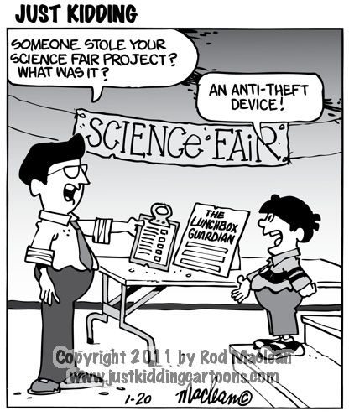Steps for a Successful Science Fair

STEP 1-Topic Selection

This is one of the most difficult parts of the process. Your idea needs to be unique or a novel approach to a topic. It needs to be significant. You should be able to answer the question, so what? The experimentation must be safe and allowable through Georgia Science & Engineering Fair (GSEF) and International Science & Engineering Fair (ISEF). Talk to your science teacher or Ms. Hendricks before you start on a topic.

[ISEF Rules Wizard](https://ruleswizard.societyforscience.org/)

[ISEF Full Rules and Regulations](https://www.societyforscience.org/isef/international-rules/rules-and-guidelines/)

Determine if the project is feasible.

|  |  |
| --- | --- |
| • Can the project be completed within the amount of time allowed? Have you considered the time needed for retrials or repeats of the experiment? For example, in plant projects, you will need a large sample of plants ready to go in two- or three-week intervals  • Do you have adequate laboratory resources or natural resources, or both, to carry out your investigation?  • Is the design of the experiment adequate? Are the effects measurable in an objective way? | . • Are there environmental concerns? For example, is it the right time of year to make your observations or collect samples?  • What is the cost of completing the project? Is it within your budget? Do you need special equipment beyond what is available? How will you get it? Have you budgeted for retrials?  • Does the project conform to ALL state or federal laws pertaining to scientific research? ( |

If you chose to work with any of the materials or organisms listed below, you will need to obtain approval from the Scientific Review Committee (SRC) before experimentation begins. Ms. Hendricks will need to schedule that by the beginning of November before experimentation begins.

* Potentially Hazardous Biological Agents (microorganisms, rDNA, human and vertebrate animal tissue, blood, body fluids, etc.) ν
* Vertebrate Animals
* Human Subjects
* Hazardous Chemicals, Activities or Devices
* Controlled Substances Obtaining approval involves additional certifications, permissions, and other paperwork.

This work is necessary for your protection, the protection of the environment, and certifies that you have treated animals, including humans, properly, and have adhered to the laws of your local town, state and the nation. Are you willing to complete this additional paperwork in order to work in restricted areas?

STEP 2-Registration for Walton STEM Expo and Science Fair

Complete the form to register. [Link](https://forms.office.com/Pages/ResponsePage.aspx?id=-x3OL5-ROEmquMR_D8kYLXtEk6IPPt5Dpvqz-pggRhRURFNWV0tRRlBOVktBMzhaV05QSjlDRlU3Ny4u)

Due by 12/8/24

STEP 3-Complete GSEF Paperwork-before experimentation

There is specific paperwork that must be completed in order to compete. Ms. Hendricks or your science teacher can help you with the forms.

|  |  |
| --- | --- |
| All projects and participants need: | Some projects will need additional forms |
| Checklist for Adult Sponsor  Student Checklist  Research Plan/Summary  Approval Form | [Required Forms Guide & Checklist](https://www.georgiacenter.uga.edu/sites/default/files/gsef-2024-required-forms-guide.pdf) |

STEP 4-Experimentation & Analysis

Make arrangements to conduct your experiment. If the experiment needs to be completed in a school lab or other specialized environment, you need to make those arrangement.



If you want to be competitive at high competition levels beyond Walton, I highly recommend that you maintain a science fair notebook. Here are some tips for the notebook.

[Scientific Notebook](https://cobbk12org-my.sharepoint.com/:b:/g/personal/tobie_hendricks_cobbk12_org/EWKufkuuSONOuaOS8U8HL80BjFJiAMTR_8bcv0l02nM5ug?e=jNeiJb)

STEP 5-Presentation Boards

It is time develop your presentation. Here are some resources to work with. If you want to be competitive at higher levels, consider formal printing of your research format to be adhered to a board. Ms. Hendricks can help you and provide suggestions.

[Display Board Hints](https://cobbk12org-my.sharepoint.com/:w:/g/personal/tobie_hendricks_cobbk12_org/EQ5_TCDh8_BJuUuk8bEuCcsB8BNdrJ5xmirCnGTmIpPtJA?e=9fBn8e)

[GSEF Display Regulations](https://www.georgiacenter.uga.edu/sites/default/files/gsef-2024-display-safety-regulations.pdf)

[One last Form-Abstract Form Required](https://www.georgiacenter.uga.edu/sites/default/files/gsef-2025-abstract-form.pdf)

STEP 6-Walton Competition

The competitive judging of projects will occur at Walton on Saturday, January 11, 2025 from 9:30-12:00 pm. We use a format of judging circles. Here are some resources for you.

[Judging Circles](https://cobbk12org-my.sharepoint.com/:w:/g/personal/tobie_hendricks_cobbk12_org/EVaJ0PhgaVNCkVmXoeC8K94BjgqSOa4l_ckJt6mV79IfdQ?e=Ia2EIa)

[Science Fair Judging Rubric](https://cobbk12org-my.sharepoint.com/:w:/g/personal/tobie_hendricks_cobbk12_org/ESBiXqUp88BCsDCGRkn-SPgBEjLvJ48_XgvPjr91ur3EuA?e=jN53p4)

[Science Fair Engineering Rubric](https://cobbk12org-my.sharepoint.com/:w:/g/personal/tobie_hendricks_cobbk12_org/EVQzFUlJrvNNjN4zsvHOhzoBivo-PMITgsf2I5Lvg54m-g?e=MDDhuj)

All competitive projects must also be on display for the Walton Science Expo on Wednesday, January 15, 2025 from 5:00-7:30 pm.

STEP 7-Additional Competitions

If your project is one of the top projects at Walton, you will move on to the Cobb/Paulding Regional Science Fair on Saturday, January 25, 2025 from 8:00 am-4:00 pm.